ARDEN MANOR RECREATION AND PARK DISTRICT
A Special District Formed In 1953
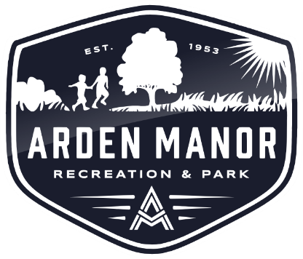
VACANT –Board Chair
John Montes - Vice Chair
Lisa Gibson - Secretary
Warren Harding – Director
Christine Arden – Director

Maria Boland – District Manager

REGULAR MEETING AGENDA
1415 Rushden Drive, Sacramento, CA 95864
Thursday, April 26, 2018, 6:30pm

VISION STATEMENT
Arden Manor Recreation and Park District, in partnership with the community, contributes to a high quality of life for residents of all ages in a safe, clean, healthy environment. Residents participate in programs that promote and enrich individual, family, and cultural harmony and prosperity.

- CALL MEETING TO ORDER
- Pledge of Allegiance
- Roll Call: Arden, Gibson, Harding, Montes,
- PUBLIC COMENTS: Under Government Code Section 54954.3 members of the public may address the Board on non-agenda items. Speakers may address Board on any agenda item during consideration of the item. Speakers are limited to three (3) minutes for their comments.

- Committee Reports
  - Jonas Larkspur Park Committee
- AGENDA APPROVAL, ADDITIONS AND / OR DELETIONS
- PRESENTATIONS –None
- CONSENT CALENDAR
- Approval of Minutes
1. March 15, 2018

- Financial Reports
1. Reports on Revenues and Expenditures (March).
2. Claims Submitted for Payment (March).
3. Employee Benefit Report (March).
- RECOMMENDED ACTION: Approve the Consent Calendar as presented.

- CORRESPONDANCE
  - FEC Park Police
  - Sacramento LAFCO

- OLD BUSINESS
  - None

- REGULAR CALENDAR

- Subject: Recommendations for filling the vacant board seat (Sutton).

- Subject: Appointment of new board member.

- Subject: Nominations and election for Board “officer” positions.

- Subject: Review and discuss District priorities list.

- Subject: Presentation and review draft social media policy.

- District Manager Report
- Maintenance, Recreation, Admin. update

- COMMENTS BY BOARD OF DIRECTORS

- AGENDA ITEMS FOR NEXT MEETING – to be scheduled

- CLOSED SESSION
The Board may hold a closed session on any subject matter authorized under the State Law Gov’t Code § 54957(b) including but not limited to pending litigation, property acquisition negotiations, and personnel matters.
- ADJOURNMENT

